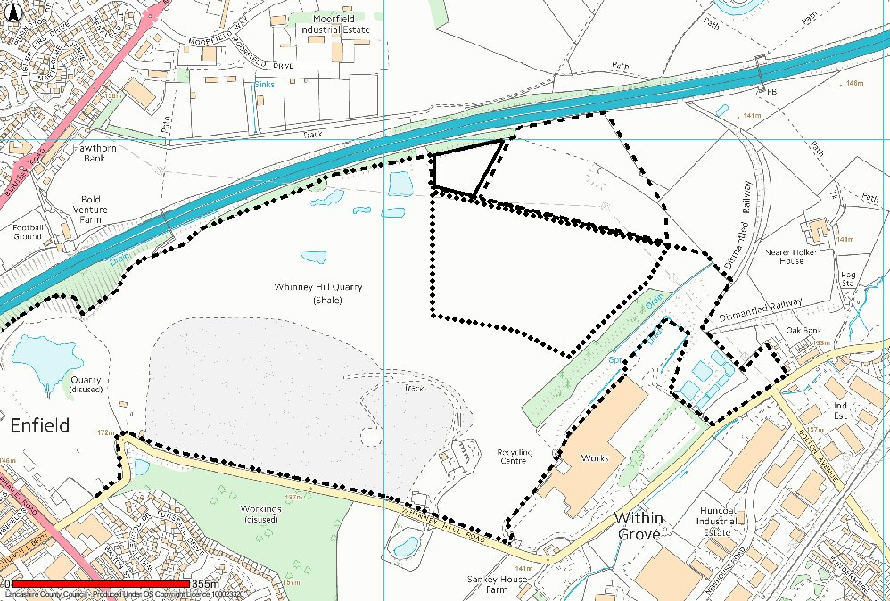
PP 11/12/012
PP 11/13/264
PP 11/94/520
PP 11/03/0017 Global Scheme

WHINNEY HILL LANDFILL SITE AND QUARRY – BOUNDARIES OF PLANNING PERMISISONS

